**Frink's Backstory**

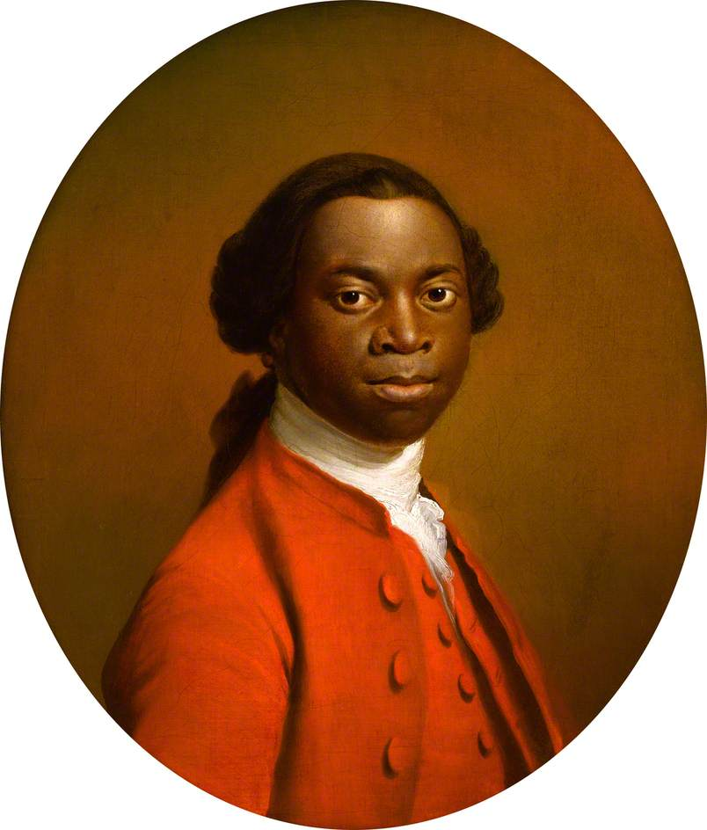Frink comes from the most distinguished house of the southern merchant aristocracy, but he tries not to think about it. His grandfather is Frenk Ka-Busanti Skhi Twsiij, head of the House Twsiij. The House of Twsiij is far wealthier and more powerful than the actual royal family, but they don't have to deal with that tiresome business of throwing one of their daughters into the volcano every ten years. Frenk Twsiij himself is not so much of a merchant prince, as he is a merchant pharaoh. In his youth, he expanded the trade enterprises he inherited, and with the traditional combination of courage, cunning and luck, grew the family fortune into the archipelago's largest collection of wealth. His only son, is Frynk Ka-Tsuva Mesh Twsiij, Frink's father. From early adolescence, it was clear that Frynk Twsiij was some kind of prodigy. The family's status demanded that Frynk be raised under close protection and supervision, but Frenk did not want to spoil his heir. He chose to furnish Frynk with an education instead of cash. At 12, Frynk was given an accounting exercise and tasked with managing a fruit juice stand that supplied nobles with refreshment as they awaited a Royal Audience. Before the year was out, Frynk had opened an ale house in every district of the capital, bought all the fresh water springs and wells in the eastern district, and cornered the market on all the archipelago's citrus.

Frenk Ka-Busanti Skhi Twsiij

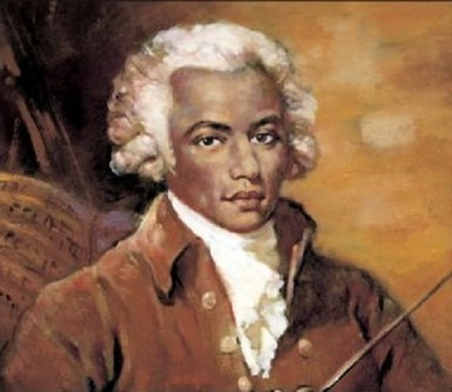Over the next four years, it became clear that the southern archipelago was too small for Frynk Twsiij. Both the assassins hired by former fruit farmers and the bevy of female suiters were becoming unmanageably aggressive. Frenk gathered the largest armada of marine mercenaries to accompany his son on a merchant voyage north to trade spices and gems for grain and gold. Alas, the armada was not enough.

Some decades before Frynk 's fateful voyage, Frink's mother, Agony, was born in a brothel. No one knows for certain who her parents were, and no one has ever really cared. Assuming that life itself is a blessing, Agony was lucky to survive her childhood. If one does not make that assumption, then Agony, and practically everyone she met before the age of ten would have been better off stillborn. It would be pointless and disgusting to relate the atrocities she suffered before she reached before her 12th year of life, but as unlikely as it seemed, she did reach it. An even less likely, she managed to start twisting fate back to some semblance of justice, by exacting revenge upon the world that had been so unfairly cruel to her. Because like Frink's father, Agony was also a prodigy: She had a spectacular genius for bloodshed. Agony's rise is not the stuff of legend, because she never left witnesses. The only thing that was widely known is that for a while, it was impossible to run a whorehouse or slave pit in the southern city's port, because all the management and customers ended up dead. Actually, people mostly concluded they were dead because it seemed impossible to live without the pieces that were left decorating the soon-to-be former establishments. But eventually it became possible for pimps and slavers to creep back into the open, because Agony became a sailor.

Frynk (Freh-Yink) Ka-Tsuva Mesh Twsiij

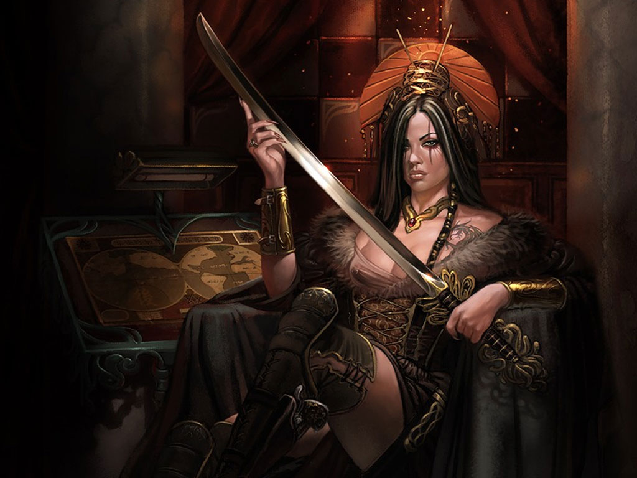

Pirate Queen Agony (Ann)

The exploits of the Pirate Queen Agony **ARE** the stuff of legend. Well, legend and a truly astonishing volume of insurance claims. The firm of Lefete, Cable & Rifnor suspected that there must be some sort of scam going on in the Southern Ocean, where merchant captains were selling their cargo on the black market, returning to port and claiming that Queen Agony had stolen their goods. LC&F sent insurance investigators with some shipments to keep a trustworthy eye on the situation. Agony sent them back to their employer with an itemized receipt branded on their chests.

Twenty five years ago, while she was the Pirate Queen, anyone who said that Agony's ship, *The Flying Merkin*, had an uncanny ability to take a prize unscathed, had better never have said it anywhere where Agony would hear about it. She used to say that she was only proud of two things in all creation, her skills at killi'n, and her skills at sail'n, and she wern't never brook no libel 'bout no unnatral cheat'n at neither. She was also intolerant of anyone correcting her grammar. It was these fearsome skills that she brought to bear on *The Sunrise Delusion,* the flagship of Frenk Twsiij's merchant fleet, and the vessel carrying what Frenk would learn was the thing he valued most in the world.

Anyone would be justified in figuring that the attack on *Sunrise Delusion* was suicidal, and that *The Flying Merkin* did not stand a chance. But the truth was that Agony was a veteran of fifty seven battles at sea, and had never suffered a single loss. Her crew believed that they were under the protection of a sea god, and were invincible. They were elated to be on her ship, and at this point they were serving just for the thrill of certain victory, as spending their share of the ship's spoils could not be as good as the rush of winning it. And sure enough, through ~~a set of bizarre circumstances~~ the captains peerless skill, *Flying Merkin* made her way through the marine mercenaries, and boarded *Sunrise Delusion*.

Frink's parents have different accounts of their meeting. Frynk says he was on deck with the captain of *Sunrise Delusion* and his bodyguard Drisk Mertck. Both the captain and Mertck ordered the crew to stand down and surrender so that Frynk could safely be handed over as a hostage, and ransom be arranged without any undo complication. Agony's story is that while they were inventorying their loot after a glorious victory, she found Frynk hiding in a barrel of spices. She also says that despite the probable 10 year age difference, it was lust at first sight, and within minutes of getting back to *The Flying Merkin* they started working on the conception of Frink's eldest sister.

No matter who you believe, the issue of ransom did become extremely complicated. Agony figured she already had more loot then she knew what to do with, so she'd rather just keep Frynk. Frynk was a 16 year old boy, and generally regarded as gorgeous. He was getting an education that even the best intentions of his father could not have supplied, as it was decided at a ship's meeting that because he was not a hostage, he was therefore loot, and as long as it was consensual, anyone on the largely female crew was entitled to the occasional share.

Through long complicated channels, Frenk Ka-Busanti Skhi Twsiij offered increasingly large ransoms for the return of his son, but Agony turned them all down. Eventually Frenk realized his son had been truly stolen, and stopped offering ransoms, and instead offered bounties for the return of his son, and of course, the head of Pirate Queen Agony.

So, for reasons known only to the gods (Frynk says he sure as hell can't explain it), Agony and Frynk found they were in love, and to be out of reach of his Frenk, they headed north to Frynk 's original destination to settle down in a southerner's enclave on the continent. They left practically all of the loot Agony had accumulated as Pirate Queen, and of course Frynk's spectacular inheritance. Once established, Frynk decided that while he loves business, money itself is not worth the risk of a High Profile. Frynk is called Freh-Yink now, and that's as close that most continentals can get to the correct pronunciation. He runs a very successful upscale inn, catering to the merchant class. In spite of himself, his inn has become famous for his side business of antiquities dealing, and the restaurant at the inn is renowned for the quality of its spiced dishes, and of course its exotic beverages.

Agony goes by the name of Ann, and now says that she is proudest of two things in all creation, her skills at lovi'n, and mother'n. And ain't non-one come farther to be as good at 'em. Frynk constantly corrects her grammar, but she tolerates it. She manages a "land-sea security company", and no-one calls it a mercenary outfit to her face. Not twice anyway.

Frink's Spell

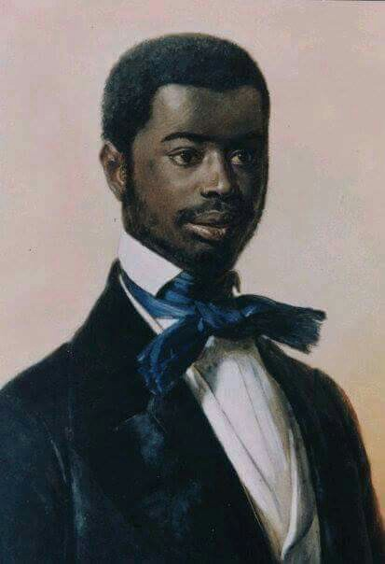Frink Ka-Agony Dzne Twsiij has eight older sisters, and no brothers. It seems that all of his sisters are superbly competent in the application of violence, either brutally or subtlety. Not that Fink was the target of their violence. Quite the contrary, Frink's sisters fought over their baby brother, not with him. Growing up, Frink was probably the least bullied kid in town, and perhaps that's what allowed his ... eccentricities to develop. Some folks figure that between his sisters, and the, ahem, intense nature of his mother, it explains why Frink tends to do what women ask him to, and why he tends to trust them, even when he should be more suspicious.

Frink Ka-Agony Dzne Twsiij

Since his youngest days, Frink has been told the myths and legends of the south, the literally epic family history, and the glorious past. He is pretty sick of it. Through his father's antiquity dealership, he has seen a lot of old stuff, and he has seen plenty of folks get all big-eyed and slack jawed over this artifact or that one, and breathlessly tell each other the ancient lore about them. Or fairy tale, whatever. Fink never cared much about the stories behind the treasures that would pass through his father's shop but even he occasionally marveled at what they could do, and was often fascinated by the mystery of how they worked. The most astonishing item he ever saw, was a miniature of Apptor, on his chariot.

Apptor was an ancient hero/demigod bla-bla-bla, but he got around on a magic chariot pulled by flying goats. The artifact that his father showed him was an impossibly detailed model of Apptor, the chariot, the goats, and some babe riding with him. It looked exactly like someone has shrunk all of them down to the size of a large bread loaf, and frozen them still. Under the right circumstances, you could even see that the hair on the rider's heads, and on the goat's chins, were made of unfathomably fine fibers. Of course, the most amazing thing was that the thing actually flew. If you crushed a pearl in the mortar and pestle that came with it, and set the dust before the goats as fodder, the whole set would come to life. The goat's hooves would glow, they would snort tiny puffs of fire, tiny Apptor would throw back his head and shake with silent laughter, and the babe would cling to Apptor an bury her face in his shoulder. Then tiny Apptor would whip the reigns and the whole thing would fly around the room for a few minutes.

The set was only in his father's hands for a day or so, but that was enough to change the course of young Frink's life. He decided that whatever it took, he was going to get a goat to breathe fire and fly. From watching the sparks fly up the chimney at the inn's fireplace, Frink had already deduced that fire and flying went together, and that he should focus on getting fire into a goat, or getting one to make fire itself. Frink knew where his mother stashed a portion of the loot from her days as Queen, so he sat down in the midst of it, picked out all the pearls, and ground them up with a mortar and pestle he found in the kitchen. He then fed the dust to the billy goat in the barnyard. Unfortunately, nothing happened. Actually, his mother made lots of things happen, but Frink didn't want any of those things to happen ever, ever, again, so he was certain he was going to have to find a way to get goats to make fire without using pearls.

It was around this time, that Frink's family began to suspect that while he did not seem to inherit his mother's remarkable talent for death dealing, he did seem to have an ~~uncanny knack~~ special aptitude regarding hidden forces and hidden elements. In his father's shop, Frink could tell when an item was special, or just old, (or fake) without being told. His family, and the Inn's staff had taken to locking up the flint and steel, because Frink seemed to find it irresistible to try using it on everything he could. But evidence was gathering that Frink did not actually need the flint and steel. If something was readily flammable, and it seemed like it would be really, really fun to burn, then you have better make sure to keep it away from Frink.

Which of course, gets us back to goats. Frink never lost sight of his long term goal. And in the course of time, he discovered that while he could not do anything with the air coming out of a goat's mouth or nose, he found that the air coming out of the back end of the goat was readily flammable. Furthermore, he found that if he concentrated **JUST SO**, he could make the goat make more of the flammable air in it's body. In fact, he can do that to almost any animal. Finally, he discovered that if he concentrated **LIKE THAT**, he could make a spark fly from a finger and ignite it into a ball of fire. Thus began the brief, but happiest period in Frink's childhood, and a time of unparalleled misery for the local livestock. When it reached the point where the farm animals would practically stampede at the sight or smell of him, his parents enrolled him in boarding school.

Now on the edge being a man, Frink still feels guilty about the excesses of his boyhood. He goes out of his way to be kind to domestic animals.

The Spell: Frink's Flaming Fart

As a cantrip, this spell magnifies the intestinal gasses of most air-breathing creatures. The gas causes pain in creatures so equipped to feel it, distraction (and perhaps embarrassment), but no damage.

This is a spell that Frink is developing long term. After he learns how to craft spells, this is the projected development path:

As a1st level spell, the magnified intestinal gasses are ignited within the creature, doing 1 d6 internal fire damage, ignoring armor. Creatures with less than 1 hit die creatures burst and die immediately. On critical save failures, creatures with 1 1 hit die creatures burst and die.

As a 3rd level spell, that caster can choose between two effects, 4d8 damage all internal as above, with 2hit die creatures bursting and doing 1d8 physical damage in a 15 foot radius, OR A 20ft cone of fire behind the target creature, doing 3d8 fire damage to all in the AOE, and 1d6 to the target creature itself.